To apply for Landowner Deer Management Permits (DMPs), sign into your DECALS account. You must already possess a current year hunting license, or click on “Buy Licenses’ and add a hunting license to your cart. You may then click on “Apply for DMP” at the top of the screen:

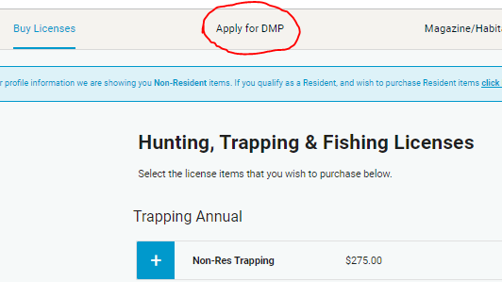

Then click on the “Apply” button:

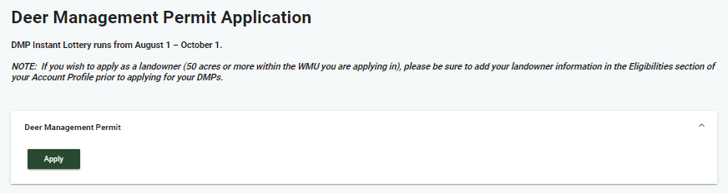

If you own 50 or more contiguous acres of land within the Wildlife Management Unit (WMU) you wish to apply for, check the “Yes” radial button and then click on “Submit”:

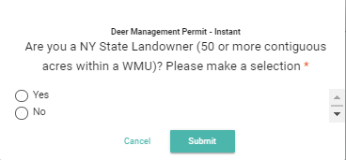

Enter the SWIS Code and Tax Map ID# for each contiguous parcel of land that makes up the 50 acres within the WMU you wish to apply for. Additionally, select the WMU from the “Wildlife Management Unit (WMU)” dropdown. Once the information is entered, click on the “Save Eligibility” button:

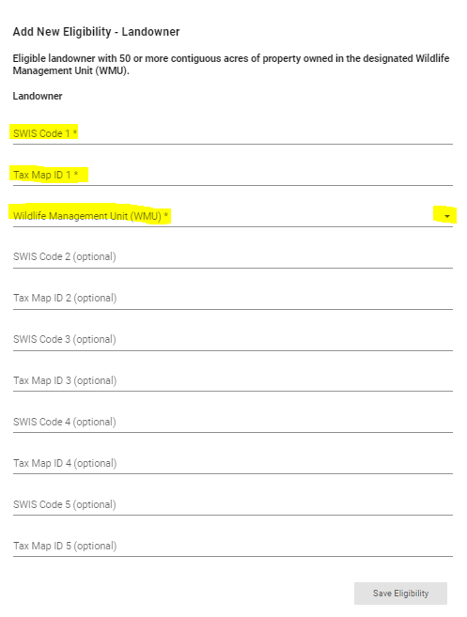

After your Landowner Eligibility information has been saved, you will be brought to the page below. You will see a list of WMUs on the left and a map to the right. You can scroll through the list of WMUs to find the unit you wish to apply for. The word “Landowner” should now display next to WMU where you own 50 or more contiguous acres.

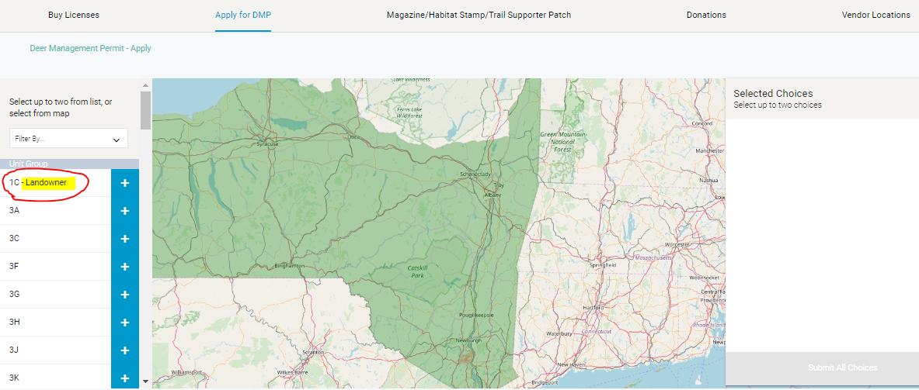

Click the “+” to the right of the WMU and check the date range in the unit pop. Once you check the date range, click on the “Submit Choice” button. Important: If you do not see “Landowner” listed next to your WMU, DO NOT continue. Go back to your profile and make sure your landowner eligibility was saved properly.

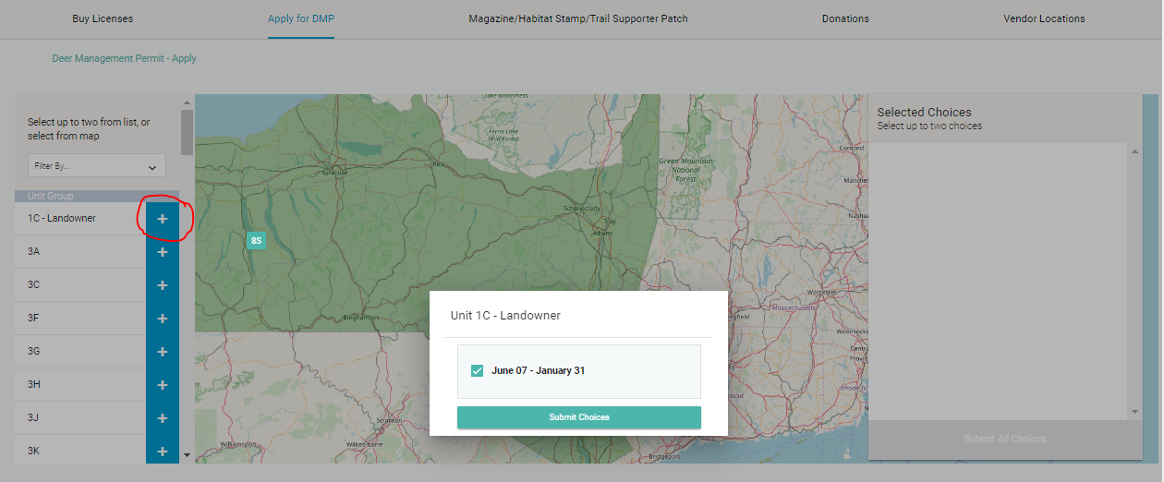

You may select up to two WMU choices. As you submit your choices, they will populate to the right of the map. It is important to note that your landowner preference will only guarantee your first choice selection.

Please review your selections before submitting. If you find an error, you can remove your choices by clicking on the “X” to the right of each choice.

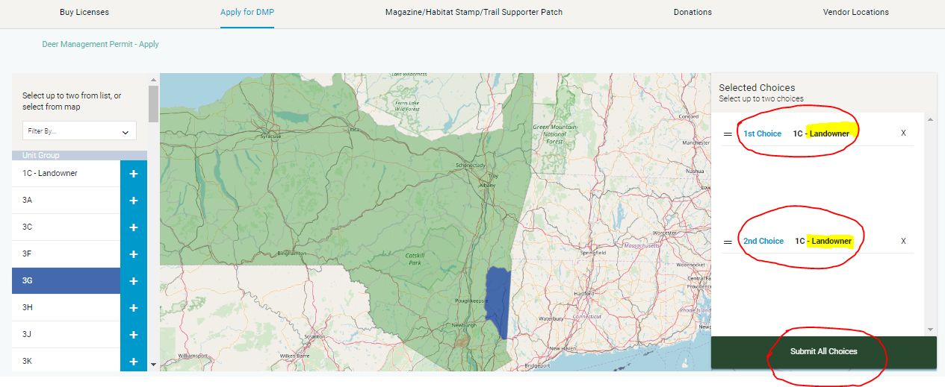

After clicking Submit, you will have one more opportunity to review your DMP selections. If everything is correct, you can move forward by clicking on the “Checkout” button. If there is something wrong with your choices, click the “Back” button. If you would like to add other items to your order (fishing license, donations, etc), click on the “Continue Shopping” button:

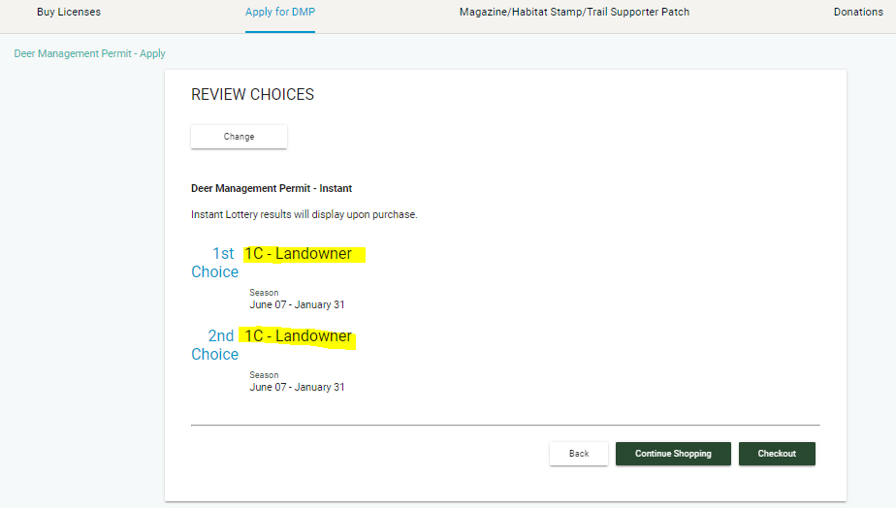

After clicking the “Checkout” button, you will be brought to the Checkout screen. You now have the opportunity to review your entire order including any other items you may wish to purchase. If everything is correct, click on the “Continue” button:

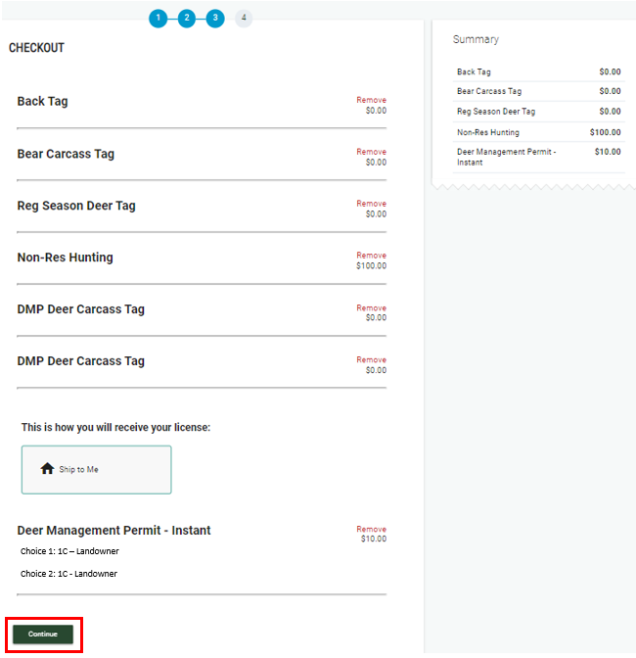

You will now have the opportunity to select your mailing address or to add a new mailing/shipping address. If your address is correct, make sure that address is selected. If you wish to add a new address, select the radial to the left of “Add New Shipping Address” and proceed to enter the shipping address. After selecting or adding your shipping address, click the “Continue” button:

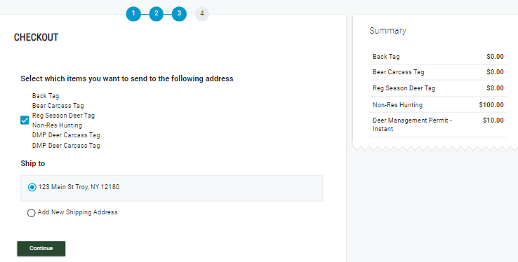

At this point you will see the details about the shipment of your order. All orders placed can take up to 14 business days to be received. If you need any items in your order in less than 14 business days you will need to make your purchase at a License Issuing Agent location. You can search for agent locations at [Vendor Locations Search](https://decals.east.licensing.app/vendor_location_search). To move forward with your order, click on the “Continue” button:

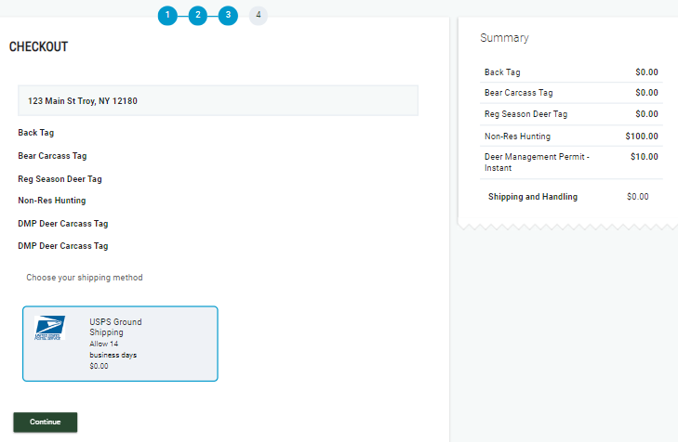

Enter your payment information, confirm or enter your billing address, and agree to the terms and conditions. If you are sure all your information is correct and you are ready to submit your order, click the “Place Order” button:

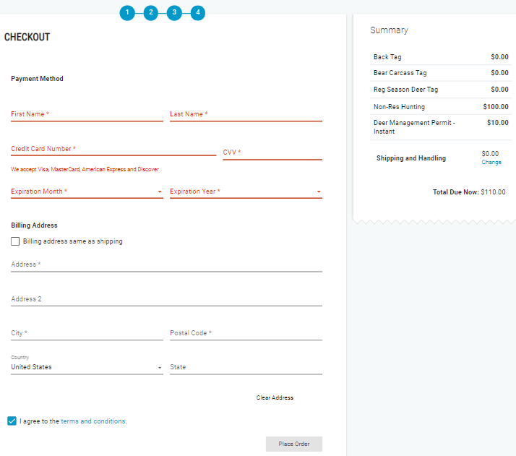

Once your order has been placed you will be presented with the results of your DMP application. After reviewing your application results, click on “Dismiss”:

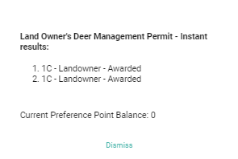

You will now be presented with a receipt of your order. You can print the receipt by clicking on the “Print Receipt” button. If you wish to go back to your account and view your profile, click on the “Back to My Account” button:

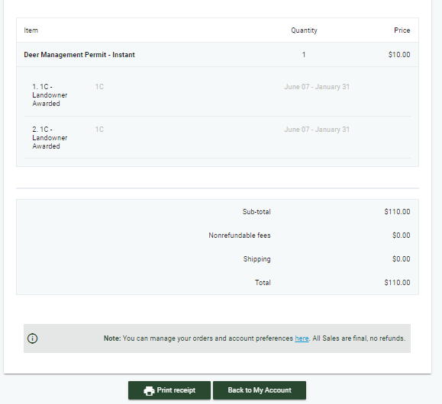

If you have issues with your order, please visit our Help Center at <https://nydec.zendesk.com/hc/en-us>

sc