**New York State Donate Life Registry**

As required by Public Health Law Section 4310, DEC’s Automated Licensing System (DECALS) began cooperating with the New York State Donate Life Registry. This registration allows people to sign up to donate their organs, eyes, and/or tissues after death. If you have questions or concerns that are not addressed on the Registry website located at [www.donatelife.ny.gov](http://www.donatelife.ny.gov), please contact Donate Life New York State by:

* Email: [registry@donatelife.ny.gov](mailto:registry@donatelife.ny.gov);
* Toll-Free Phone Number: 1-866-NY-DONOR;
* Mail: Donate Life New York State, 185 Jordan Rd, Troy NY 12180

**Registering as an Organ, Eye and/or Tissue Donor:**

Upon logging into your DECALS customer profile, you will be asked if you would like to be added to the NYS Donate Life Registry. You will have the option to select “Yes” or to “Skip this question”.

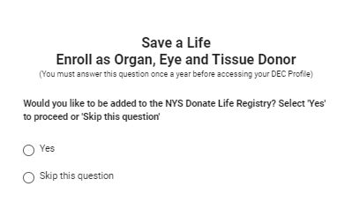

If you select “Yes” you will be presented with the dialogue box shown below. You will need to check the “I agree” box, electronically sign using your first and last name, provide your date of birth and then click the “Submit” button. If you choose “Skip this question” you will be asked about becoming a donor again in the next calendar year.

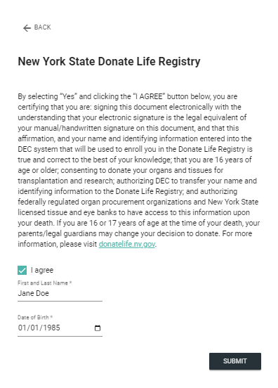

Once submitted, your information will be forwarded to the NYS Donate Life Registry, and you will be registered as a donor. Following your registration, you can expect to get a welcome letter that contains information about your registration, how to contact the Donate Life Registry and how to access your account online.